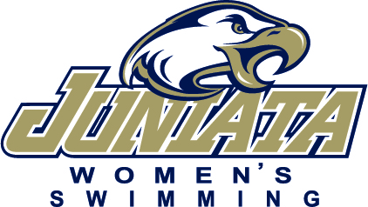

2026 Juniata College Women’s Swimming Roster

Name Event Cl. Hometown/High School
Kimber Beeler Freestyle/Breaststroke So. Shippensburg, Pa. / Shippensburg Area Senior HS
Danielle Cline Freestyle/IM So. Clearfield, Pa. / Clearfield Area Jr-Sr HS
Lena Englerth Breaststroke/Freestyle So. York, Pa. / York Suburban HS
Grace Finch Sprint Freestyle/Butterfly Sr. North Haven, Conn. / North Haven HS
Lakelynn Godfrey Freestyle Fy. York, Pa. / Dallastown Area HS
Maegan Jordan IM/Backstroke/Distance Freestyle Gr. Irwin, Pa. / Norwin High School
Norah McClain Breaststroke/Freestyle So. Huntingdon, Pa. / Huntingdon Area HS
Megan Mikell Freestyle/Backstroke/Butterfly So. Vienna, Pa. / James Madison HS
MacKenzie Moore IM/ Freestyle Fy. Honolulu, Hi / Abeka Academy
Snabu Neupane Backstroke Sr. Kathmandu, Nepal / Army Public School, Pithoragarh, India
Abby Ortiz Distance Freestyle/Backstroke So. Teaneck, Nj. / Teaneck HS
Ellie Parton Freestyle Fy. Leander, Tx. / Redlands HS
Eleanor Smith Freestyle/IM Fy. Tacoma, Wa. / Stadium HS
Miriam Struble-Hedstrom Butterfly/IM So. Manchester, In. / Manchester Jr/Sr HS
Coltan Swarts Backstroke/Freestyle Fy. Lincoln, Ne. / Lincoln HS
Juliana Varner Sprint Freestyle/Breaststroke Jr. Monroeton, Pa. / Towanda Area HS
Delany Wetzel Distance Freestyle/IM/Butterfly So. Mechanicsville, Pa. / Hanover HS
Kasey Williams Freestyle/Butterfly Fy. Greensburg, Pa. / Hempfield Area HS

Head Coach: Kyle Russell (Salisbury University ’21) Third Season
Assistant Coach: Ashley Derrick (Susquehanna ’25) First Season
Pronunciation Guide:
Juniata- Joo-nee-at-uh
Megan Mikell - Mick-ehl
Snabu Neupane- Snah-boo New-pon-ay
Coltan Swarts- Sw-orts

