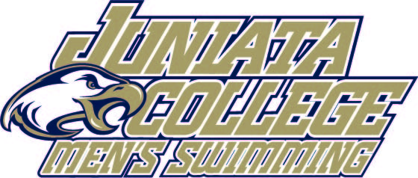
2026 Juniata College Men’s Swimming Roster

Name Event Cl. Hometown/High School
Max Baronner Sprint/IM/BR So. Hollidaysburg, Pa. / Hollidaysburg Senior HS
Kevin Bowser IM/FL So. Slippery Rock, Pa. / Slippery Rock Area HS
Wyatt Cole FL/FR/IM Fy. Bridgewater, Va. / Turner Ashby HS
Will Dovey FL/IM/BK So. McConnellsburg, Pa. / McConnellsburg HS
Cody Hartle IM/FI Fy. Slippery Rock, Pa. / Slippery Rock HS
Yui Inagi IM/FL/BR Fy. Sayama City, JP /
Isaac March Sprint /BR Sr. Washington, Pa. / Trinity High School
Jim Oster FR/BR So. Lusby, Md. / Patuxent HS
Marshall Radonovich IM/FR/BK So. Frederick, Md. / Urbana HS
Christian Rota FL/BK/FR So. Lancaster, Pa. / Lampeter-Strasburg HS
Matthew Rota IM/FI/BR Fy. Lampeter, Pa. Lampeter-Strasburg HS
Ben Schultz Sprint Fy. Elkton, Pa. / Rising Sun HS
Logan Stewart BK/FR Fy. Inwood, WV / Musselman HS
Matthew Tiernan FR/BK Sr. Willow Grove, Pa. / Upper Moreland HS
Head Coach: Kyle Russell (Salisbury University ’21) Third Season
Assistant Coach: Ashley Derrick (Susquehanna ’25) First Season
Pronunciation Guide:
Juniata- Joo-nee-at-uh
Will Dovey- Dough-vee
Cody Hartle- Huar-tull
Yui Inagi- You-ee In-ah-gee
Jim Oster- Ooo-ster
Marshall Radonovich- Rad-ahn-oh-vich

